SRI CHANDRASEKHARENDRA SARASWATHI VISWA MAHAVIDYALAYA
(UNIVERSITY ESTABLISHED UNDER SECTION 3 OF UGC ACT 1956)
ENATHUR,KANCHIPURAM – 631561
DEPARTMENT OF COMPUTER SCIENCE & ENGINEERING



DATABASE MANAGEMENT SYSTEMS LAB RECORD

Name : E.SRI THANMAI
Reg. No : 11239A026
Class : 3rd year
Course : BE-CSE
Faculty in charge : Dr. D. THAMARAISELVI
SRI CHANDRASEKHARENDRA SARASWATHI VISWA MAHAVIDYALAYA
(UNIVERSITY ESTABLISHED UNDER SECTION 3 OF UGC ACT 1956)
ENATHUR,KANCHIPURAM – 631561
DEPARTMENT OF COMPUTER SCIENCE & ENGINEERING
BONAFIDE CERTIFICATE

This is to certify that this is the bonafide record of work done by MR/MS E.SRI THANMAI with Reg.no 11239A026 of III-B.E-CSE in the DATABASE MANAGEMENT SYSTEMS LAB during the academic year 2025-2026
Station: Enathur
Date : -11-2025

Staff-in-charge Head of the department
Submitted for the practical examination held on__________________

Examiner-1 Examiner-2
DBMS LAB RECORD

List of Programs:

Si  No. | Date | Contents | Page  Number | Staff  Initials
1 | 12-08-2025 | Creation of a database and writing SQL queries to retrieve information from the Database.
2 | 12-08-2025 | Performing Insertion, Deletion, Modifying, Altering, Updating and Viewing records based on conditions.
`3 | 19-08-2025 | Performing Queries using ANY,  ALL, IN, Exists, NOT EXISTS,  UNION, INTERSECT,  Constraints etc.
4 | 19-08-2025 | Queries using Aggregate functions, GROUP BY and HAVING .
5 | 2-09-2025 | Creation of Views, Synonyms,  Sequence, Indexes, Save point.
6 | 9-09-2025 | Creating a database to set various constraints.
7 | 23-09-2025 | Creating relationship between the databases and performing join, sub queries
8a | 14-10-2025 | Write a PL/SQL block to satisfy some conditions by accepting input from the user.
8b | 14-10-2025 | Write a PL/SQL block that handles all types of exceptions
8c | 21-10-2025 | Creation of Procedures and Function
8d | 21-10-2025 | Creation of database triggers (Creation of insert trigger,  delete trigger, update trigger)
8e | 21-10-2025 | Creation of database with implicit and explicit cursor
Exp 1- Creation of a database and writing SQL queries to retrieve information from the Database.

Aim: To create a database and writing SQL queries to retrieve information from the table
Algorithm:
STEP 1: Start the DBMS
STEP 2: Connect to the database (DB)
STEP 3: Create the table with its essential attributes.
Step 5: Type the commands for creating tables and perform various operations on the tables.
Step 6: The output is displayed.
Step7: Stop the program
Program:
create table student_marks(Roll_no varchar(20), CGPA float(20), Gender char(10));
insert into student_marks values('11169A055', 8.8, 'M');
insert into student_marks values('11169A048',9.5,'M');
insert into student_marks values('11169A052',8.0,'M');
insert into student_marks values('11169A053',8.32,'M');
insert into student_marks values('11169A046',9.8,'M');
insert into student_marks values('11169A014',5.5,'F');
select * from student_marks;
create table student_details(Name char(20),Roll_no varchar(20));
insert into student_details values('Rahul','11169A069');
insert into student_details values('Uday','11169A048');
insert into student_details values('Akhil','11169A033');
insert into student_details values('Mahesh','11169A035');
insert into student_details values('Sumanth','11169A046');
insert into student_details values('Teja','11169A117');
select * from student_details;
select student_marks.Roll_no,student_marks.CGPA,student_marks.Gender,student_details.name from student_marks,student_details
where student_marks.Roll_no=student_details.Roll_no;
delete from student_marks where gender='F';
select *from student_marks ;
update student_details set name = upper(name); select *from student_details ;
select student_marks.Roll_no,student_marks.cgpa,student_marks.gender,student_details.name from student_marks,student_details where student_marks.roll_no=student_details.roll_no;
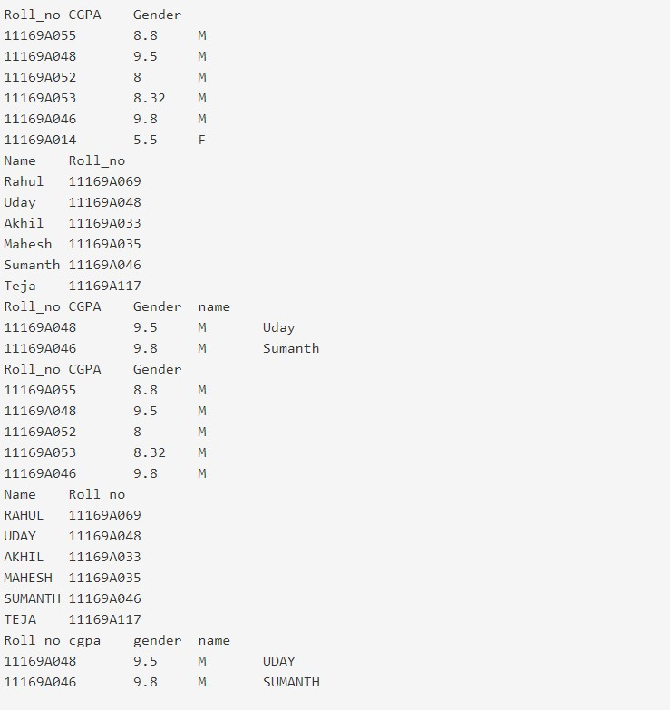RESULT: Thus, the commands are executed successfully.
Output:

EXP 2- Performing Insertion, Deletion, Modifying, Altering, Updating and Viewing records based on conditions.

AIM: To perform insertion,deletion,modifying,altering,updating,viewing of records
ALGORITHM:
STEP 1: Start the DBMS
STEP 2: Connect to the database (DB)
STEP 3: Create the table with its essential attributes.
STEP 4: Insert the record into table based on some condition using WHERE CLAUSE
STEP 5: Update the existing records into the table based on some condition
STEP 6: Delete the records in to the table based on some condition
STEP 7: Use commit for permanently save the records
STEP 8: Stop the program
PROGRAM:
create table stud(Si_no integer primary key,Name text,Reg_no integer, Dept text); insert into stud values ('1','Varun','168','CSE'); insert into stud values ('2','Anurag','169','CSE'); insert into stud values ('3','Vallab','162','CSE'); insert into stud values ('4','Aniket','152','CSE'); select*from stud; insert into stud(Si_no,Name,Reg_no,Dept) values('5','Vatsa','176','CSE'); select*from stud; delete from stud where Si_no = 4; select*from stud;
update stud set Name = 'Kashyap' , Reg_no = '57' , Dept = 'ECE' where Si_no = 2; select Name , Dept from stud where Si_no = 2; alter table stud Add Year integer; select*from stud; update stud set Year = 3 where Si_no<=5; select*from stud;
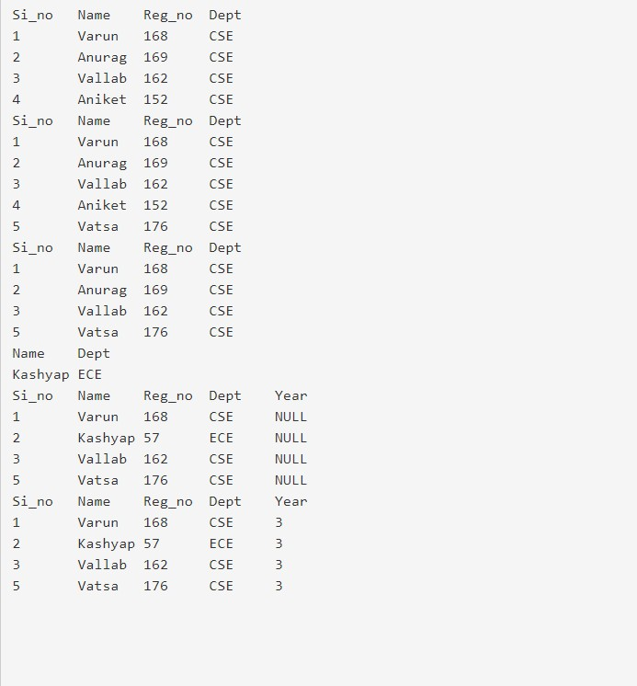
OUTPUT:

RESULT: Thus, the commands are executed successfully.
EXP 3- Performing Queries using ANY, ALL, IN, Exists, NOT EXISTS, UNION, INTERSECT, Constraints etc.

AIM: To perform queries using any,all,in,exists,not exists,union,intersect,constraints.
ALGORITHM:
STEP 1: Start the DBMS
STEP 2: Connect to the database (DB)
STEP 3: Create the table with its essential attributes.
STEP4 : Insert the record into table based on some condition
STEP5: Print the output using any,all,exist,not exist,union,intersect,constraint
STEP6: Stop the program
Program:
create table color (name varchar(10),id char(10),marks char(10),age varchar(10)); insert into color (name,id,marks,age) values('pink',100,60,16); insert into color (name,id,marks,age) values('black',101,50,12); insert into color (name,id,marks,age) values('red',111,70,15); insert into color (name,id,marks,age) values('blue',112,90,18); select *from color; create table blur(name varchar(10),id char(10),marks varchar(10)); insert into blur (name,id,marks) values('pink',100,50); insert into blur (name,id,marks) values('violet',101,50); insert into blur (name,id,marks) values('radium',111,80); insert into blur (name,id,marks) values('grey',112,90); select *from blur;
ANY:
select name ,age from color where id> any(select id from blur where id=111)
ALL:
select name ,age from color where id>all(select id from blur where id=100)
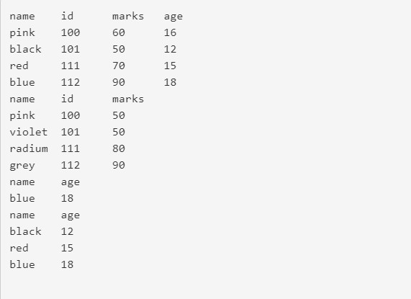
OUTPUT:

EXISTS:
SELECT name,id,marks,age from color where name in ('pink','red');
SELECT name FROM color WHERE EXISTS (SELECT name FROM blur
WHERE color.id=blur.id and marks>20);
OUTPUT: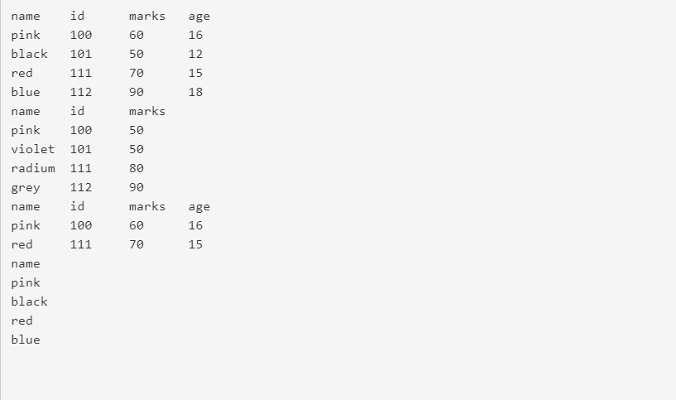

UNION:
select name,id from color union select name,id from blur;

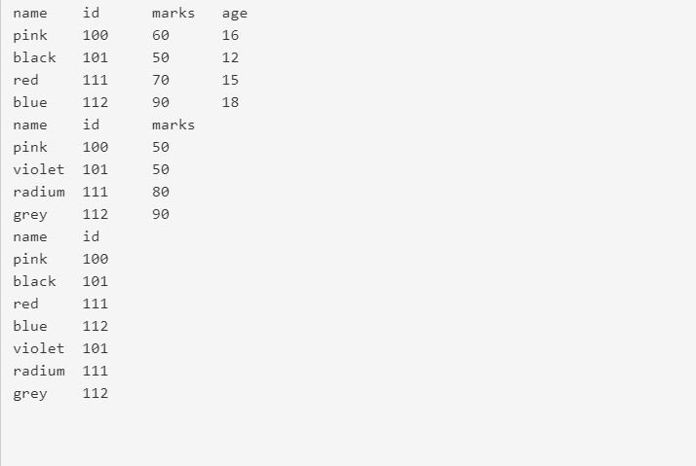
OUTPUT:

INTERSECT:
select name,id from color intersect select name,id from blur;
OUTPUT:
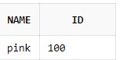

RESULT: Thus, the commands are executed successfully.
EXP 4- Queries using Aggregate functions, GROUP BY and HAVING.

AIM: To perform queries using Aggregate functions, Group by and Having
ALGORITHM:
STEP 1: Start the DBMS
STEP 2: Connect to the database (DB)
STEP 3: Create the table with its essential attributes.
STEP4: Insert the record into table based on some condition
STEP5: Print the output using the aggregate functions,group by,having
STEP6: Stop the program
PROGRAM:
create table stud(Si_no integer primary key,Name text,Reg_no integer, Dept text, State text); insert into stud values ('1','Varun','168','CSE','AP'); insert into stud values ('2','Anurag','169','CSE','AP'); insert into stud values ('3','Vallab','162','CSE','TN'); insert into stud values ('4','Aniket','152','CSE','TN'); insert into stud values ('5','Sarath','162','CSE','TN'); insert into stud values ('6','Mehar','034','CSE','AP'); select *from stud; select count(Si_no), State from stud group by State order by count(Si_no) DESC; select count(Si_no), State from stud
group by State having count(Si_no) > 10; select max(Reg_no) from stud; select avg(Reg_no) from stud; select sum(Reg_no) from stud; select min(Reg_no) from stud; select count(Reg_no) from stud; select upper(Name) from stud; select lower(Name) from stud; select ascii(Name) from stud; select length(Name) from stud;
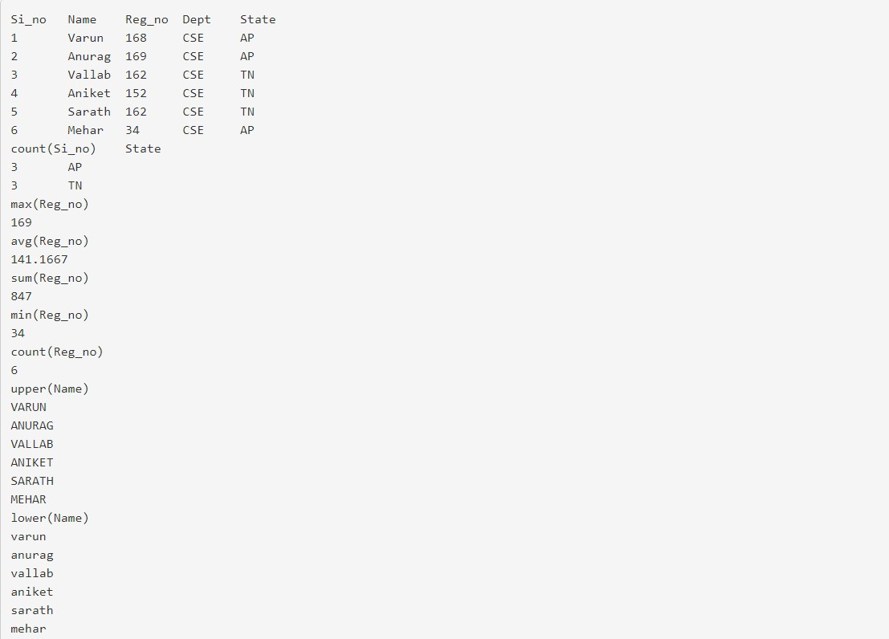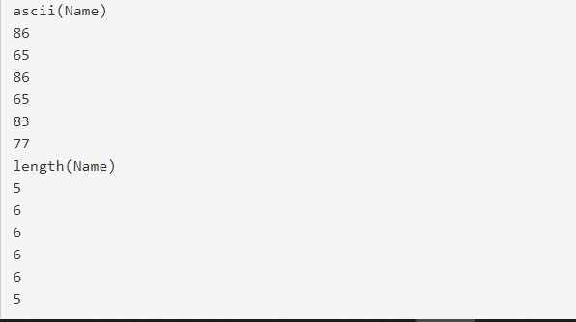
OUTPUT:

RESULT: Thus, the commands are executed successfully.
EXP 5- Creation of Views, Synonyms, Sequence, Indexes, Save point.

AIM: To create views, synonyms, sequence, index, save point
ALGORITHM:
STEP 1: Start the DBMS.
STEP 2: Connect to the existing database(DB) STEP 3: Create the table with its essential attributes.
STEP 4: Insert record values into the table.
STEP 5: Create the view from the above created table.
STEP 6: Display the data presented on the VIEW.
STEP 7: Insert the records into the VIEW,
STEP 8: Check the database object table and view the inserted values presented
STEP 9: Execute different Commands and extract information from the View.
STEP 10: Stop the DBMS.
Program
create table stud(Si_no integer primary key,Name text,Reg_no integer, Dept text); insert into stud values (1,'Varun',168,'CSE'); insert into stud values (2,'Anurag',169,'CSE'); insert into stud values (3,'Vallab',162,'CSE'); insert into stud values (4,'Aniket',152,'CSE'); select*from stud; insert into stud(Si_no,Name,Reg_no,Dept) values('5','Vatsa','176','CSE'); select*from stud;

VIEWS:
create view student AS select Name , Dept from stud where Si_no < 3; select*from student;
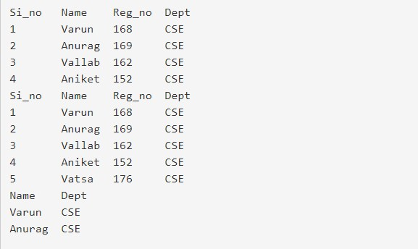

RESULT: Thus, the commands are executed successfully.

EXP 6- Creating a database to set various constraints.
AIM: To create a database to set various constraints
Algorithm:
STEP 1: Start the DBMS.
STEP 2: Connect to the existing database (DB)
STEP 3: Create the table with its essential constraint.
STEP 4: Insert record values into the table and then check the constraint.
STEP 5: disable the constraints and insert the values into the table.
STEP 6: if you want to re-enable the constraint then enable it.
STEP 7: Stop the DBMS.
PROGRAM:
CREATE TABLE EMPLOYEE(
ID INT NOT NULL UNIQUE,
NAME VARCHAR (20) NOT NULL ,
AGE INT NOT NULL CHECK (AGE >= 18) ,
ADDRESS CHAR (25) ,
SALARY DECIMAL (8, 2) DEFAULT 5000.00,
PRIMARY KEY (ID)
);
INSERT INTO EMPLOYEE VALUES(1,'SESHU',40,'KANCHI',10000);
INSERT INTO EMPLOYEE VALUES(2,'VARUN',24,'KADAPA',12000);
INSERT INTO EMPLOYEE VALUES(3,'MEHAR',19,'RAJAMUNDRY',13000);
INSERT INTO EMPLOYEE VALUES(4,'SARATH',18,'KAKINADA',14000);
SELECT*FROM EMPLOYEE;

CREATE TABLE YOF(
ID INT NOT NULL,
YEAR INT NOT NULL,
EMPLOYEE_ID INT references EMPLOYEE(ID),
AMOUNT double,
PRIMARY KEY (ID)
);
INSERT INTO YOF VALUES(1,2020,128, 200000);
INSERT INTO YOF VALUES(2,2012,190, 2045567);
INSERT INTO YOF VALUES(3,2018,54, 346439); INSERT INTO YOF VALUES(4,2004,6, 4059693);
ALTER TABLE YOF
ADD FOREIGN KEY (Employee_ID) REFERENCES EMPLOYEE (ID);
SELECT*FROM YOF; OUTPUT:
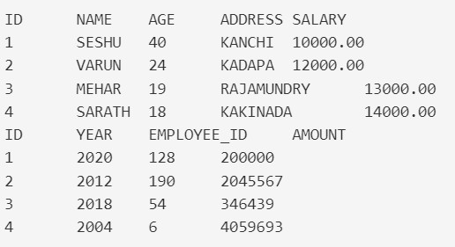

RESULT: Thus, the commands are executed successfully.
EXP 7- Creating relationship between the databases and performing join, sub queries

AIM: To create relationship between the databases and performing the join, sub queries
ALGORITHM:
STEP 1: Start the program.
STEP 2: Create two different tables with its essential attributes.
STEP 3: Insert attribute values into the table.
STEP 4: Create the table object for easy reference.
STEP 5: Join two tables by using the JOIN operator.
STEP 6: Display the result of the result table.
STEP 7: Stop the program.
PROGRAM:
CREATE TABLE PRIMARY customers(customer_idINTAUTO_INCREMENT KEY,customer_nameVARCHAR(100) );
CREATE TABLE orders ( order_id INT AUTO_INCREMENT PRIMARY KEY, customer_id INT,amount DOUBLE, FOREIGN KEY (customer_id) REFERENCES customers(customer_id) );
INSERT INTO customers (`customer_id`, `customer_name`) VALUES
(1, 'Adam'), (2, 'Andy'), (3, 'Joe'), (4, 'Sandy');
INSERT INTO orders (`order_id`, `customer_id`, `amount`) VALUES
(1, 1, 19.99), (2, 1, 35.15), (3, 3, 17.56), (4, 4, 12.34);
SELECT*FROM customers; JOINS:
SELECT*FROM orders;
SELECT orders.order_id, customers.Customer_name
FROM orders
INNER JOIN customers ON orders.customer_id=customers.customer_id;
SELECT*FROM customers;
SELECT customers.customer_name, orders.order_id
FROM customers
LEFT JOIN orders ON customers.customer_id = orders.customer_id
ORDER BY customers.customer_name;
SELECT*FROM customers;
SELECT customers.customer_name, orders.order_id
FROM customers
RIGHT JOIN orders ON customers.customer_id = orders.customer_id ORDER BY customers.customer_name; select*from customers;

OUTPUT: 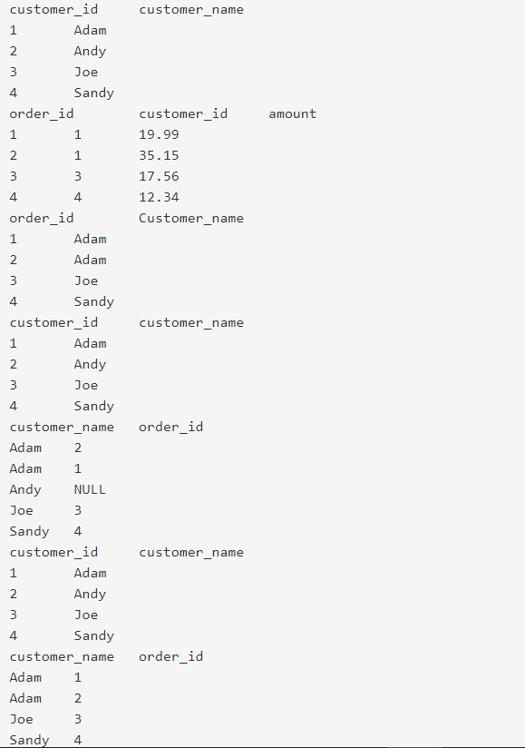SUB QUERIES:

CREATE TABLE customers ( customer_id INT AUTO_INCREMENT PRIMARY KEY, customer_name VARCHAR(100) );
CREATE TABLE orders ( order_id INT AUTO_INCREMENT PRIMARY KEY, customer_id INT, amount DOUBLE,
FOREIGN KEY (customer_id) REFERENCES customers(customer_id)
);
INSERT INTO customers (`customer_id`, `customer_name`) VALUES
(1, 'Adam'), (2, 'Andy'), (3, 'Joe'), (4, 'Sandy');
INSERT INTO orders (`order_id`, `customer_id`, `amount`) VALUES
(1, 1, 19.99), (2, 1, 35.15), (3, 3, 17.56), (4, 4, 12.34);
SELECT DISTINCT customer_id, customer_name FROM customers; update customers set customer_name='vijay' where customer_id=1; select * from customers order by customer_name desc; select customer_name as cname from customers;

OUTPUT:
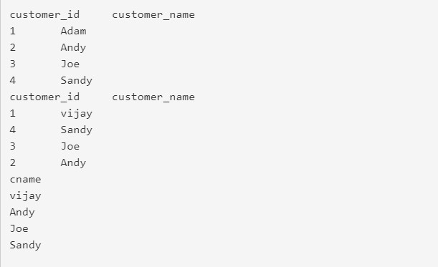

RESULT: Thus, the commands are executed successfully.

EXP 8a- Write a PL/SQL block to satisfy some conditions by accepting input from the user.

AIM: To write PL/SQL commands by accepting user input
ALGORITHM:
STEP 1: Start the program.
STEP 2: Create the table with its essential attributes.
STEP 3: Insert attribute values into the table.
STEP 4: Create the PL/SQL Block with necessary blocks.
STEP 5: Declare the necessary variable in the declaration section STEP 6: write the main program logics in the begin block.
STEP 7: if you want to access the table use the SQL statement.
STEP 8: if you want to solve any exception, write the exception name with WHEN statement
STEP 9: Execute the PL/SQL block.
STEP 10: Give the input values or validate the information from the tables.
STEP 11: Stop the program.
PROGRAM:
declare b varchar2(10) := 'SCSVMV'; c varchar2(10); l number(2); i number(2); g number(2); d varchar2(10); begin l:=length(b);
g:=l; for i in 1..l loop c:=substr(b,g,1); g := g - 1; d := d |
c; end loop; dbms_output.put_line('revised string is'); dbms_output.put_line(d); end;

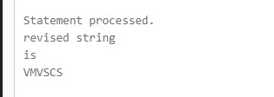
OUTPUT
:

RESULT: Thus, the commands are executed successfully.

EXP 8b- Write a PL/SQL block that handles all types of exceptions

AIM: To write PL/SQL commands to handle all types of exceptions
ALGORITHM:
STEP1: Start the program.
STEP2: Create a table with some valid data.
STEP3: write the PL/SQL program to handle the exception-on-exception block
STEP4: Execute the PL/SQL program and give the input values or make the error on the table data.
STEP5: Display the PL/SQL program error message.
STEP6: Stop the program.
PROGRAM:
Declare
A number := 10;
Begin
DBMS_OUTPUT.PUT_LINE('HELLO1');
Declare a number := 20;
Begin
DBMS_OUTPUT.PUT_LINE('HELLO2');
DBMS_OUTPUT.PUT_LINE(a);
DBMS_OUTPUT.PUT_LINE(A);
END;
DBMS_OUTPUT.PUT_LINE('HELLO3');
DBMS_OUTPUT.PUT_LINE(a); --ERROR
END;

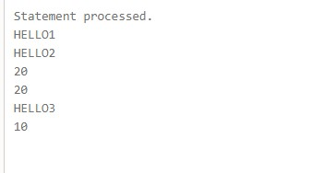
OUTPUT:

RESULT: Thus, the commands are executed successfully.
EXP 8c- Creation of Procedures and Function

AIM: To create procedures and functions
ALGORITHM:
STEP1: Start the program.
STEP2: Create a table with table name stud_exam
STEP3: Insert the values into the table and Calculate total and average of each student
STEP4: Execute the procedure function for the student who gets above 60%.
STEP5: Display the total and average of student
STEP6: Terminate the application
PROGRAM:
CREATE OR REPLACE PROCEDURE greetings
AS
BEGIN
dbms_output.put_line('Hello World!');
END;
/
BEGIN
greetings;
END;
/
DECLARE
a number; b number; number; PROCEDURE findMin(x IN number, y IN number, z OUT number) IS
BEGIN
IF x < y THEN
z:= x;
ELSE
z:= y;
END IF;
END; BEGIN
a:= 23; b:= 45; findMin(a, b, c); dbms_output.put_line(' Minimum of (23, 45) : ' || c);
END;
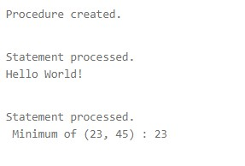
OUTPUT:

RESULT: Thus, the commands are executed successfully.
EXP 8d- Creation of database triggers (Creation of insert trigger, delete trigger, update trigger)

AIM: To create database triggers
ALGORITHM:
Step1. Start the program.
Step2. Create the table with its essential attributes.
Step3. Insert attribute values into the table.
Step4. Create the trigger for a particular table
Step5. Specify when the trigger is to be fired - before or after
Step6. Specify DML statement that invokes the trigger - UPDATE, DELETE, or INSERT
Step7. Specify the type of trigger whether row-level trigger or not Step8. Condition to filter rows.
Step9. PL/SQL block that is to be executed when the trigger is fired.
Step10. Modify the specified table to fire the trigger.
Step11. Display the trigger message for the particular kind of modification
Step12. Stop the program.
PROGRAM:
create table customers(id number(5),name varchar(10),age number(5),address varchar(10),salary number(20)); insert into customers values(1,'Ramesh',32,'Ahmedabad',2000); insert into customers values(2,'Khilan',25,'Delhi',1500); insert into customers values(3,'Kaushik',23,'Kota',2000); insert into customers values(4,'Chaitali',25,'Mumbai',6500); insert into customers values(5,'Hardik',27,'Bhopal',8500); insert into customers values(6,'Kolam',22,'MP',4500);
select *from customers; create or replace trigger display_salary_changes before delete or insert or update on customers for each row when(new.id > 0)
declare
sal_diff number;
begin
sal_diff := :new.salary -:old.salary; dbms_output.put_line('old salary: '|| :old.salary); dbms_output.put_line('new salary: '|| :new.salary); dbms_output.put_line('salary: '|| sal_diff); end;
/
insert into customers(id,name,age,address,salary)values(7,'kriti',22,'hp',7500); select *from customers; update customers set salary = salary + (age*100) where id =2; select *from customers ;

OUTPUT:
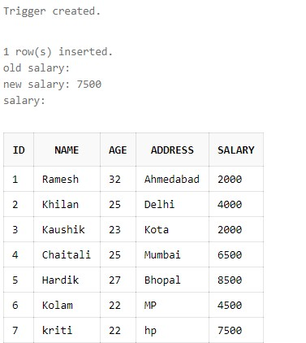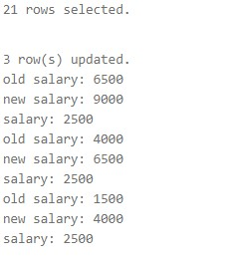

Result: Thus, the commands are executed successfully.
EXP 8e- Creation of database with implicit and explicit cursor

AIM: To create database with explicit and implicit cursor
ALGORITHM:
STEP 1: Start the DBMS
STEP 2: Connect to the database (DB)
STEP 3: Create the table with its essential attributes.
STEP4 : Insert the record into table based on some condition
STEP5: Declare the required variables and constants
STEP6: Begin the program and fetch the values using the loops
STEP7: Stop the program
PROGRAM:
create table customers(id number(5),name varchar(10),age number(5),address varchar(10),salary number(20)); insert into customers values(1,'Ramesh',32,'Ahmedabad',2000); insert into customers values(2,'Khilan',25,'Delhi',1500); insert into customers values(3,'Kaushik',23,'Kota',2000); insert into customers values(4,'Chaitali',25,'Mumbai',6500); insert into customers values(5,'Hardik',27,'Bhopal',8500); insert into customers values(6,'Kolam',22,'MP',4500); select *from customers;

DECLARE
c_id customers.id%type; c_name customers.name%type; c_addr customers.address%type; CURSOR c_customers is
SELECT id, name, address FROM customers;
BEGIN
OPEN c_customers;
LOOP
FETCH c_customers into c_id, c_name, c_addr; EXIT WHEN c_customers%notfound;
dbms_output.put_line(c_id || ' ' || c_name || ' ' || c_addr);
END LOOP;
CLOSE c_customers;
END;
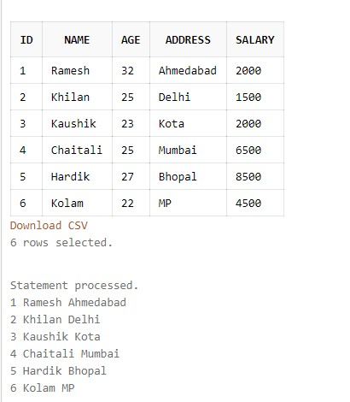
OUTPUT:

RESULT: Thus, the commands are executed successfully.

